Part 1:

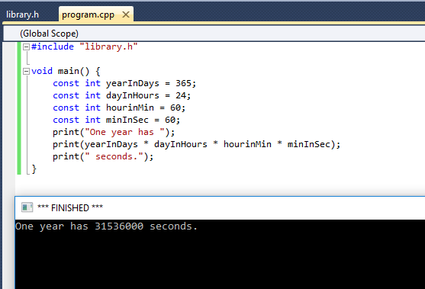

Code:

#include "library.h"

void main() {

const int yearInDays = 365;

const int dayInHours = 24;

const int hourinMin = 60;

const int minInSec = 60;

print("One year has ");

print(yearInDays * dayInHours * hourinMin * minInSec);

print(" seconds.");

}

Part 2:

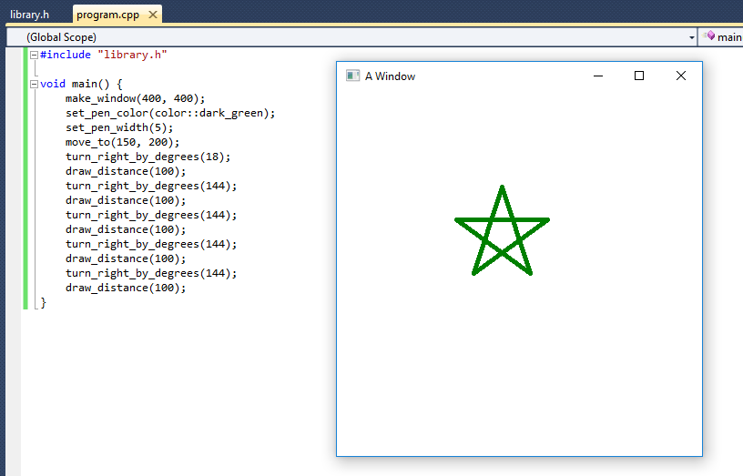

Code:

#include "library.h"

void main() {

make_window(400, 400);

set_pen_color(color::dark_green);

set_pen_width(5);

move_to(150, 200);

turn_right_by_degrees(18);

draw_distance(100);

turn_right_by_degrees(144);

draw_distance(100);

turn_right_by_degrees(144);

draw_distance(100);

turn_right_by_degrees(144);

draw_distance(100);

turn_right_by_degrees(144);

draw_distance(100);

}

Part 3:

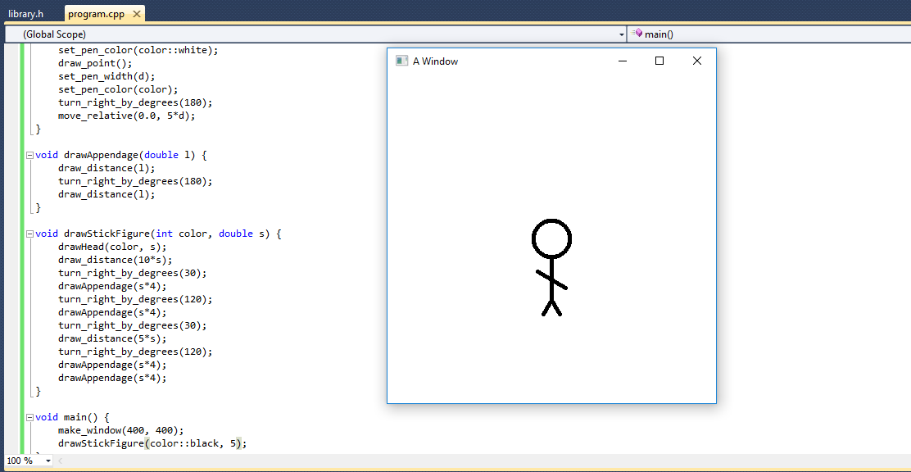

Code:

#include "library.h"

void drawHead(int color, double d) {

move_to(200, 200);

set_pen_width(10*d);

draw_point();

set_pen_width(8*d);

set_pen_color(color::white);

draw_point();

set_pen_width(d);

set_pen_color(color);

turn_right_by_degrees(180);

move_relative(0.0, 5*d);

}

void drawAppendage(double l) {

draw_distance(l);

turn_right_by_degrees(180);

draw_distance(l);

}

void drawStickFigure(int color, double s) {

set_pen_color(color);

drawHead(color, s);

draw_distance(10*s);

turn_right_by_degrees(30);

drawAppendage(s*4);

turn_right_by_degrees(120);

drawAppendage(s*4);

turn_right_by_degrees(30);

draw_distance(5*s);

turn_right_by_degrees(120);

drawAppendage(s*4);

drawAppendage(s*4);

}

void main() {

make_window(400, 400);

drawStickFigure(color::black, 5);

}